Write short notes on following

1. **Scrum :** Scrum is a framework used for long-term and complex projects . Scrum team usually consists of 5 to 9 people .

*Usage*

Scrum may be the best choice when the exact amount of work can’t be estimated and the release date is not fixed . Scrum is used for projects that require stakeholder feedback which may greatly affect project requirements .

Benefits

* Higher Productivity
* Better-quality products
* Reduced time to market
* Improved stakeholder satisfaction
* Better team dynamics
* Happier employees

Cons

* Scrum often leads to scope creep , due to the lack of a definite end-date .
* Chances of project failure are high if individuals aren’t very committed or cooperative .
* Adapting Scrum in large teams is challenging .

Components

The Scrum team

* Scrum master - Making sure team is as productive as possible .
* Product owner - Key stakeholder or key user .
* Development team - Anyone who participates in the creation of deliverables .

The Scrum events

* Sprint planning meeting - Scrum team selects the work they can complete during the coming sprint .
* Daily scrum - Each day a brief meeting is conducted to set the context for each day’s work .
* Sprint retrospective - At the end of each sprint , a meeting is scheduled in which the team reflects on how well scrum is working for them and what changes they may wish to make .
* Sprint review meeting - Team shows what they accomplished during the sprint .

Scrum artifacts - sprint backlog ( items taken from product backlog for sprint ) .

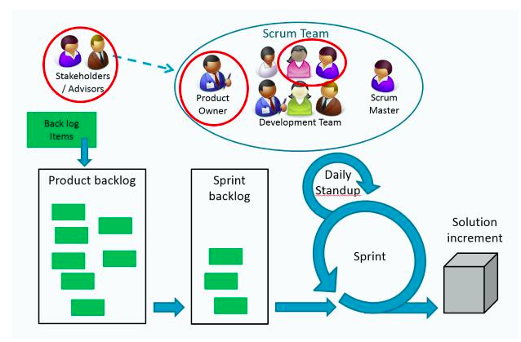

2. **Lean Development -** Lean Software Development is an agile framework based on optimizing development time and resources , eliminating waste, and ultimately delivering only what the product needs . Team releases a bare-minimum version of its product to the market ,learns from users what they like , don’t like and want to be added and then iterates based on this feedback .

*Usage*

Organisation must have an outstanding development team, and trust that team implicitly,for this approach to be successful as it forces the team to ruthlessly cut away any activity that doesn’t directly affect the final product .

Benefits

* Streamlined approach allows more functionality to be delivered in less time .
* Eliminates unnecessary activity and as a result can reduce costs .
* Empowers the development team to make decisions .

Cons

* Heavily dependent on team members , can lead to failure if proper documentation is not maintained .

**3 Extreme programming (XP) -** An agile software development framework that aims to produce high quality software , and higher quality of life for the development team. XP is set up for small groups of programmers .

Usage

In many software environments dynamically changing requirements is the only constant . XP is used when customers don’t have a firm idea of what the system should do and hence there are dynamic changes in requirements . The XP practices are set up to mitigate the risk and increase the likelihood of success .

Benefits

* Whole process in XP is visible and accountable . Developers commit what they will accomplish and show progress .
* It allows companies to save costs and time required for project realization .

Cons

* This methodology does not measure code quality code assurance . It may cause defects in the initial code .

Values

* Communication - XP stresses the importance of the appropriate kind of communication -face to face communication with aim of a white board .
* Simplicity - Keep the design of the system as simple as possible so that it is easier to maintain, support and revise .
* Feedback - Through constant feedback teams can identify areas for improvement and revise their practices .
* Courage - You need courage to accept and act on feedback even when it’s difficult to accept .
* Respect - Team members should respect each other in order to communicate with each other,provide and accept feedback.

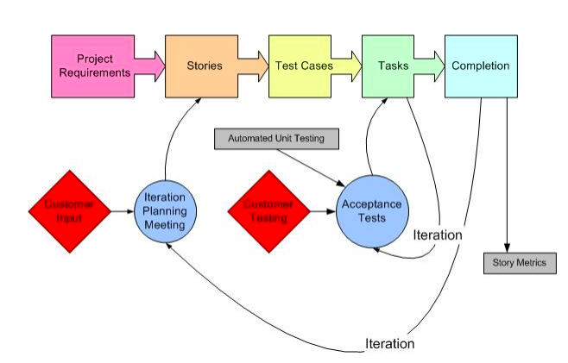

**4 Adaptive Software Development (ASD) -** It is a method to build complex software and systems . ASD focuses on human collaborations and self-organisation .

Phases

* Speculation - Project is initiated and planning is conducted .
* Collaboration - It needs the workers to be motivated . People working together must trust each others to criticize , assist , work as hard as possible , possession of skill set and communicate problems to find effective solutions .
* Learning - Learning helps the workers to increase their level of understanding over the project . Team has to increase their knowledge constantly,using practices such as - technical reviews , project retrospective and customer focus groups .

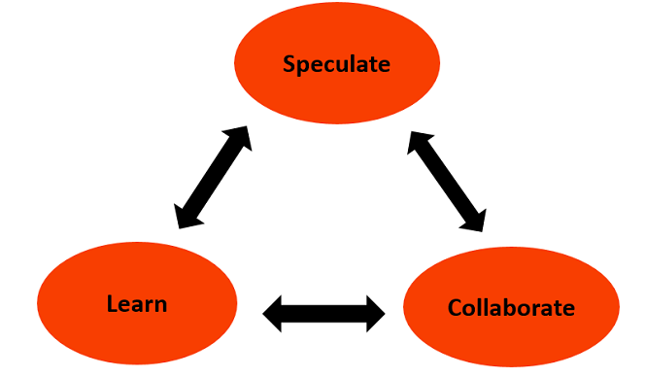

**5 Feature Driven Development (FDD) -** Organizes software development around making progress on features .

Usage

FDD is used while working on a large-scale software project . But this methodology relies heavily on chief developers and has a top-down decision making approach .

Project Lifecycle

* Develop an overall model
* Build a feature list
* Plan by feature
* Design by feature
* Build by feature

Benefits

* Allows more rapid development .
* Allows larger teams to move products forward with continuous success .
* Leverages pre-defined development standards, so teams are able to move quickly .

Cons

* Does not work efficiently for smaller projects
* Less written documentation, which can lead to confusion .
* Highly dependent on lead developers or programmers .

